Explore Weather Trends-Udacity Data Analyst Project 1

Name:V.Samhitha

Date:9-7-2020

City: Hyderabad/India

______________________________________________________________

**Overview**

As per the project description, in this project i analysed the global temperature and the temperature of the city i live in. I compare both global and local temperatures and deduce to the necessary conclusions and observations.

**Outline:**

I have used SQL to extract the required data

1. To extract the global data i used

***select *from global_data;***

2. To extract the city data i used

***select year, avg_temp from city_data where city='Hyderabad' and country='India'***

Excel sheet to fill up the five year moving average

Then Python to draw the line graphs

I have encountered few missing values in the city data which i filled with the previous value. And to further have a smooth process i have included only the years common in both the data sets.

**Line Chart with global and local temperature trends**

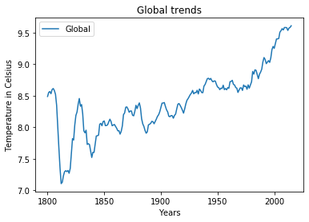 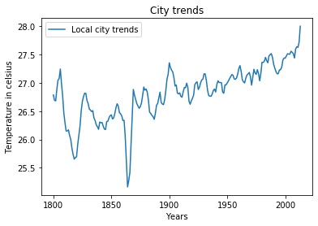

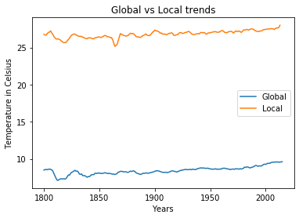

Three graphs global trend,local trend and the comparision between global and local trends.

**Observations:**

1. Over a decade Hyderabad, India (Local) temperature is higher than the global temperature that is, My city is hotter.

2. The Global trend says that the temperature is rising since 1800's to 2000's

3. The City temperature is also increasing through time but certain abrupt falling down of temperature can also be witnessed.

4. The average temperature of Hyderabad is in between 25 and 27 C

5. The average temperature of the World is in between 7 and 9 C

4.The world is getting hotter

5. The trend of rise in temperature is consistent since past century.

**Final Conclusion:**

The temperature of the world is rising and it is getting hotter by time.